MOTILAL NEHRU NATIONAL INSTITUTE OF TECNOLOGY

ALLAHABAD (U.P)



PROJECT REPORT ON

Exam Seating Arrangement

Coordinated by Instructed by

Dr. Rajitha Bakthula Ms. Roshni Singh.

# Acknowledgement

The satisfaction that accompanies that the successful completion of any task would be incomplete without the mention of people whose ceaseless cooperation made it possible, whose constant guidance and encouragement crown all efforts with success.

We are grateful to our project coordinator **Dr. Rajitha Bakthula** and project guide **Ms. Roshni Singh** for the guidance, inspiration and constructive suggestion that helpful us in the preparation of this project.

We also thank our colleagues who have helped in successful completion of the project.

**Names of students Signature**

Deendayal Gour(2018CA41)

Jay Kumar(2018CA61)

Abhishek Keer(2018CA26)

Rahul Rathore(2018CA70)

Satish Randawa(2018CA58)

# Table of Contents

Problem Statement (4)

Introduction (5)

System Analysis… (6)

Abstract… (7)

Module Description (8-10)

Entity Relationship Diagram (11)

Used Technologies (12-14)

Project Snapshot (15-24)

Future Scope…………………………………………………………….. (25)

Requirement Specifications… (26)

# Problem Statement

The existing system is very slow and in efficient. Report generation is also not an easy task in the current situation. Also if the report is generated then calculations are done manually that leads to more errors. There is a lot of manual work involved in the current system and mistake in one detail can lead to the wrong generation of the page. No proper collection of requirements leads to a huge problem for this system. This system is to enhance manual work and also more energy is wasted to allocate the seating arrangement.

# Disadvantages of the existing system

The current system is manual so all the records are maintained manually. So the seating arrangement of students cannot be determined if updating is not done.

* Time Consuming Less
* Efficient More manual Work Required
* Less Accurate
* Not User-Friendly
* Difficult in hall ticket generatio

**Introduction**

Exam Hall Seating Arrangement System is an online process developed to simplify examination hall allotment and seating arrangement. It facilitates to access the examination information of a particular student in a particular class. The purpose of developing an exam hall seating arrangement system is to computerize the traditional way of conducting exams. Another purpose for developing this software is to generate the seating arrangement report automatically during exams at the end of the session or in between the session. The scope of the project is the system on which the software is installed, i.e.

The project is developed as a windows based application, and it will work for a particular institute. Most students are facing many problems for finding the exam hall and their seats respectively. A newly invented concept can aid the students in checking their exam halls. This helps them to identify the floor or get directions to their respective halls without delays. Students details have information about all the students who attend the examination. It contains the name of the student, Hall Ticket No, Branch of the student and the hall number. Hall Details have a total number of halls available in the institution and the name of the hall. Batch details contain department details for ex., Computer Science, Biology, Chemistry, Mathematics, etc., and the examination timings details have total timing allotted to students and hall, etc. This project keeps track of various details in modules such as Students Details, Examination Timing Details, and Hall Details with the proper descriptions.

# System Analysis

**Introduction :-**

Analysis is can be defined as breaking up of any whole so as to find out their nature, function etc. It defines design as to make preliminary sketches of: to sketch a pattern or outline for plan. To plan and carry out especially by artistic arrangement or in a skill full wall. System analysis and design can be characterized as a set of techniques and processes, a community of interest, a culture and an intellectual orientation. The various tasks in the system analysis include the following.

* Understanding application.
* Planning.
* Scheduling.
* Developing candidate solution.
* Performing trade studies.
* Performing cost benefit analysis.
* Recommending alternative solutions.
* Supervising, installing and maintaining the system.
* This system manages to the analysis of the report creation and develops manual entry of the Exam seating plan.

**Abstract**

Examination Hall Management System is developed for the college to simplify the allocation of halls to students during exams. It facilitates to access the examination information of a particular student in a particular Class. The information is sorted information by Registration Num, which will be provided by the teacher for a respective department through Excel file.

# PURPOSE

The purpose of developing exam hall seating arrangement system is to computerize the traditional way of conducting the exams. Another purpose for developing this software is to generate the seating arrangement report automatically during exams at the end of the session or in between the session.

# 2.SCOPE

The scope of the project is to design a web interface and it will be deploy on web from where user can create their account and give the information about the exam ,examination place and student details and site will generate a pdf contain the seating plan of student in give exam halls.

# Module Description

Exam seating arrangement sytsem for allotment of seat to the students in examination. Seating arrangements can be easily generated in this proposed system by that user can generate the pdf as per the requirement and their wish for the duration of month or the day.

# System Function

System has two types of accessing modes: - 1.Administrator (Admin)

2.User

# Admin Module

In this module admin will look how many user exist in System. Admin have privilege to remove user from database completely.

In this application admin does not have more things to do but there is a future scope to increase the functionality of admin such as he will be able to choose the pattern of seating for each user.

# User Module

In this module if user does not have account on site then first user have to register on site and give the information regarding user details.

Then user have to login into page and go through the following step to generate examination seating plan.

If user have previous plan then he/she can edit the previous plan details and use the same plan for examination seating arrangement. Otherwise have to follow these steps.

STEPS FOR GENERATING SEATING ARRANGEMENT

Step 1: **(Add my plan)**

After successful login a new page will open on which user have to navigate through my plan navigation bar on clicking it a form will generate in which user have to fill the information about the examination such as Date and time of exam ,

Name of exam, Name of college/school, Address of school/college after filling these information user have to click on submit button.

Step 2: **(Add room details)**

On clicking the submit button user will we redirected to another page where user

can add the count of room and enter details of floor number, name of rooms, their rows , their column and on clicking the submit button all the room details will be saved in database.

Step 3: **(Student details)**

In this user have to upload all details of students by excel file. For any problem regarding the excel file format we have provided sample template. Student detail should be in excel file otherwise it will give us error. On clicking upload button all the student details will get store in studentdetails table in database.

Format of student details should be like this:

|  |  |  |  |  |
| --- | --- | --- | --- | --- |
| Reg.no /Enrollment no. | Name | Class/Course | Semester | Branch |

Step 4 : **(Assign seat)**

After giving all the information of rooms and students. Application will fetch the data from the studentdetails table in database and show you the table on page containing the details of courses and their semester with a checkbox on each row

now user have to select the courses for which he/she want to plan seating arrangement in given rooms. User have to select at least two course or can select all the course.

On clicking the submit button a new html page will open contain the table corresponding to each room which contains the reg.no . of student arranged in

ABAB format.

There is a download button on clicking , it will generate a pdf file which contains the details of student arranged in table.

**Extra points**

User can update its profile detail going through update profile nav bar.

Here user can update password,email,mobile and address.

User can also view its previous seating plans and room details and can also edit and delete them.

# ER-DIAGRAM

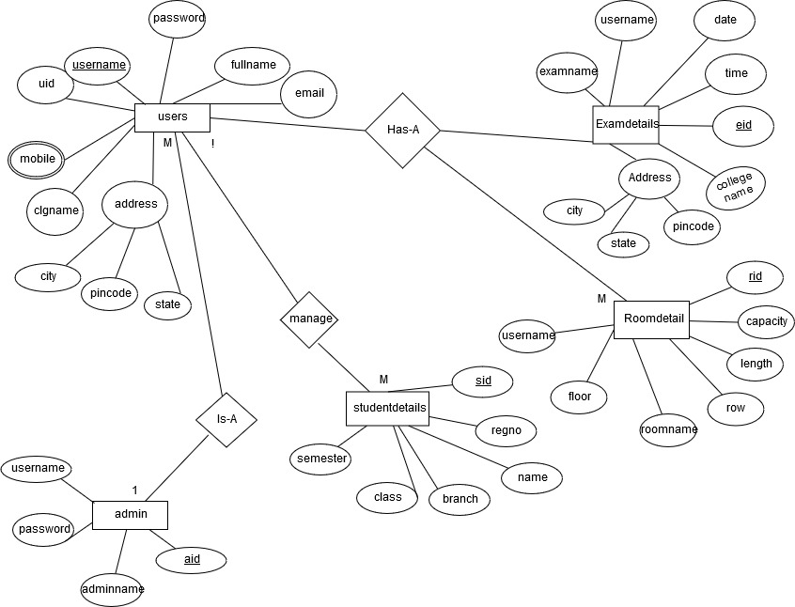

**Used technologies**

**Front-end**

**Hypertext Markup Language** (**HTML**)

**HTML** is the standard markup language for documents designed to be displayed in a web browser. It can be assisted by technologies such as Cascading Style Sheets (CSS) and scripting languages such as JavaScript. HTML describes the structure of a web page semantically and originally included cues for the appearance of the document. HTML elements are the building blocks of HTML pages. With HTML constructs, images and other objects such as interactive forms may be embedded into the rendered page. HTML provides a means to create structured documents by denoting structural semantics for text such as headings, paragraphs, lists, links, quotes and other items. HTML elements are delineated by *tags*, written using angle brackets.

**Cascading Style Sheets (CSS)**

**CSS** is a style sheet language used for describing the presentation of a document written in a markup language like HTML. CSS is a cornerstone technology of the World Wide Web, alongside HTML and JavaScript. CSS is designed to enable the separation of presentation and content, including layout, colors, and fonts. This separation can improve content accessibility, provide more

flexibility and control in the specification of presentation characteristics, enable multiple web pages to share formatting by specifying the relevant CSS in a separate

.Separation of formatting and content also makes it feasible to present the same markup page in different styles for different rendering methods, such as on-screen, in print, by voice (via speech-based browser or screen reader), and on Braille-based tactile devices. CSS also has rules for alternate formatting if the content is accessed on a mobile device.

**Bootstrap-Web Framework**

**Bootstrap** originally named Twitter Blueprint, was developed by Mark Otto and Jacob Thornton at Twitter as a framework to encourage consistency across internal tools. A super small group of developers build a new internal tool to document and share common design patterns. Bootstrap is a web framework that focuses on simplifying the development of informative web pages. The result is a uniform appearance for prose, tables and form elements across web browsers. In addition, developers can take advantage of CSS classes defined in Bootstrap to further customize the appearance of their contents. For example, Bootstrap has provisioned for light- and dark-colored tables, page headings, more prominent pull quotes, and text with a highlight. Bootstrap also comes with several JavaScript components in the form of jQuery plugins. They provide additional user interface elements such as dialog boxes, tooltips, and carousels. Each Bootstrap component consists of an HTML structure, CSS declarations, and in some cases accompanying JavaScript code. They also extend the functionality of some existing interface elements, including for example an auto-complete function for input fields.

**Javascript**

JavaScript is a very powerful **client-side scripting language**. JavaScript is used mainly for enhancing the interaction of a user with the webpage. In other words, you can make your webpage more lively and interactive with the help of JavaScript. JavaScript is also being used widely in game development.

The language was initially called LiveScript and was later renamed JavaScript. There are many programmers who think that JavaScript and java are the same. In fact**,** JavaScript and Java are very much unrelated. Java is a very complex programming language whereas JavaScript is only a scripting language. The syntax of JavaScript is mostly influenced by the programming language

# Back-end

**NODEJS.**

Node.js is a server-side platform built on Chrome’s JavaScript runtime for easily building fast and scalable network applications. It is an open source, cross-platform runtime environment for developing server-side and networking applications. Node.js applications are written in JavaScript, but runs on the server. When running JavaScript in an application the code runs on the web browser and completes once all code has been run. Node.js runs on the server continuously until it is stopped manually..

**What is it used for ?**

Node.js has the ability to create non-blocking applications which makes handling requests very fast. Because of thisNode.js is mainly used for I/O bound applications, data intensive real-time applications, single page applications,JSON APIs, and data-streaming applications. It is not recommended to use Node.js for CPU-heavy applications

**MySQL**

MySQL is the world's most popular open source database. With its proven performance, reliability and ease-of-use, MySQL has become the leading database choice for web-based applications, used by high profile web properties including Facebook, Twitter, YouTube, Yahoo! and many more. MySQL is free and open-source software under the terms of the GNU General Public License. It was owned and sponsored by the Swedish company MySQL AB, which was bought by Sun Microsystems In 2010, when Oracle acquired Sun, Widenius forked the open-source MySQL project to create MariaDB. MySQL is offered under two different editions: the open source MySQL Community Server and the proprietary Enterprise Server.

**SAMPLE SCREEN SHOTS**

**Home**

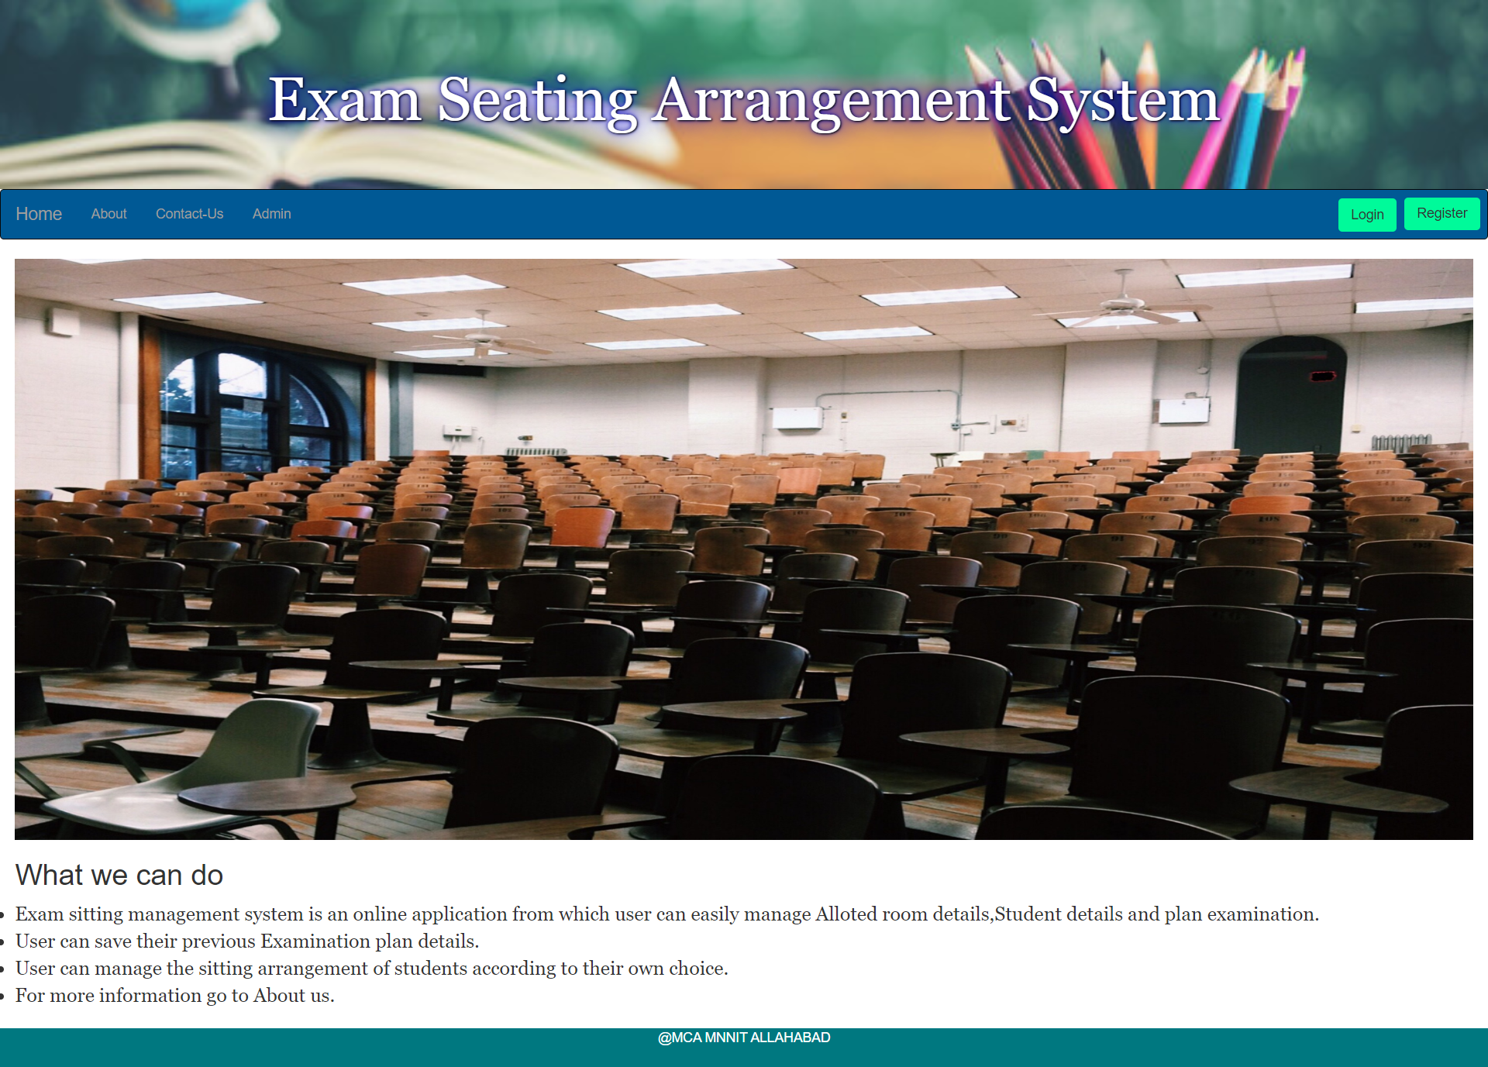

**About**

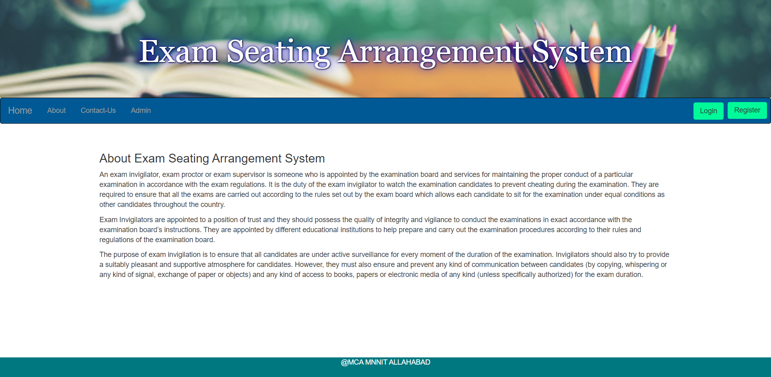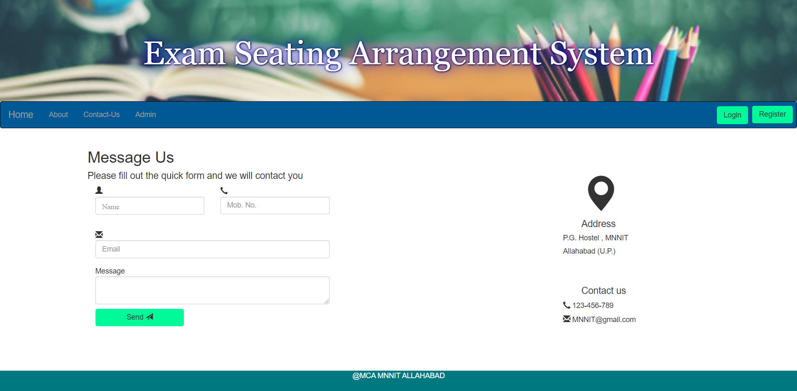

**Signup From**

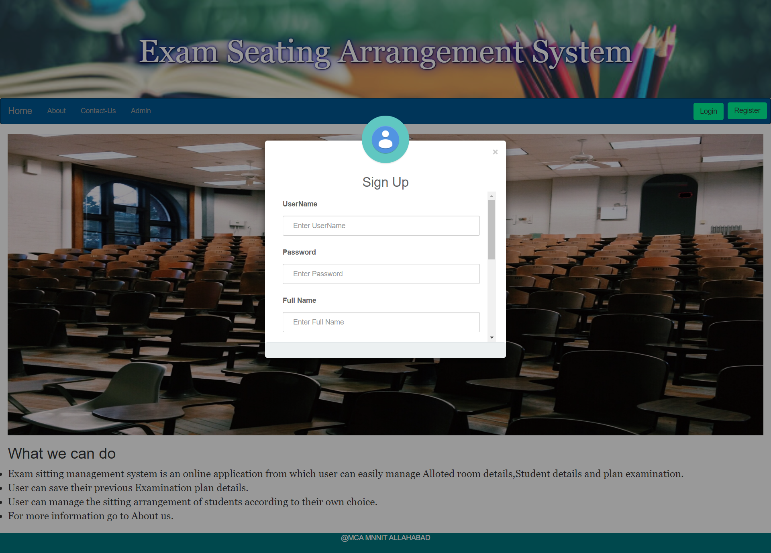

Login Form

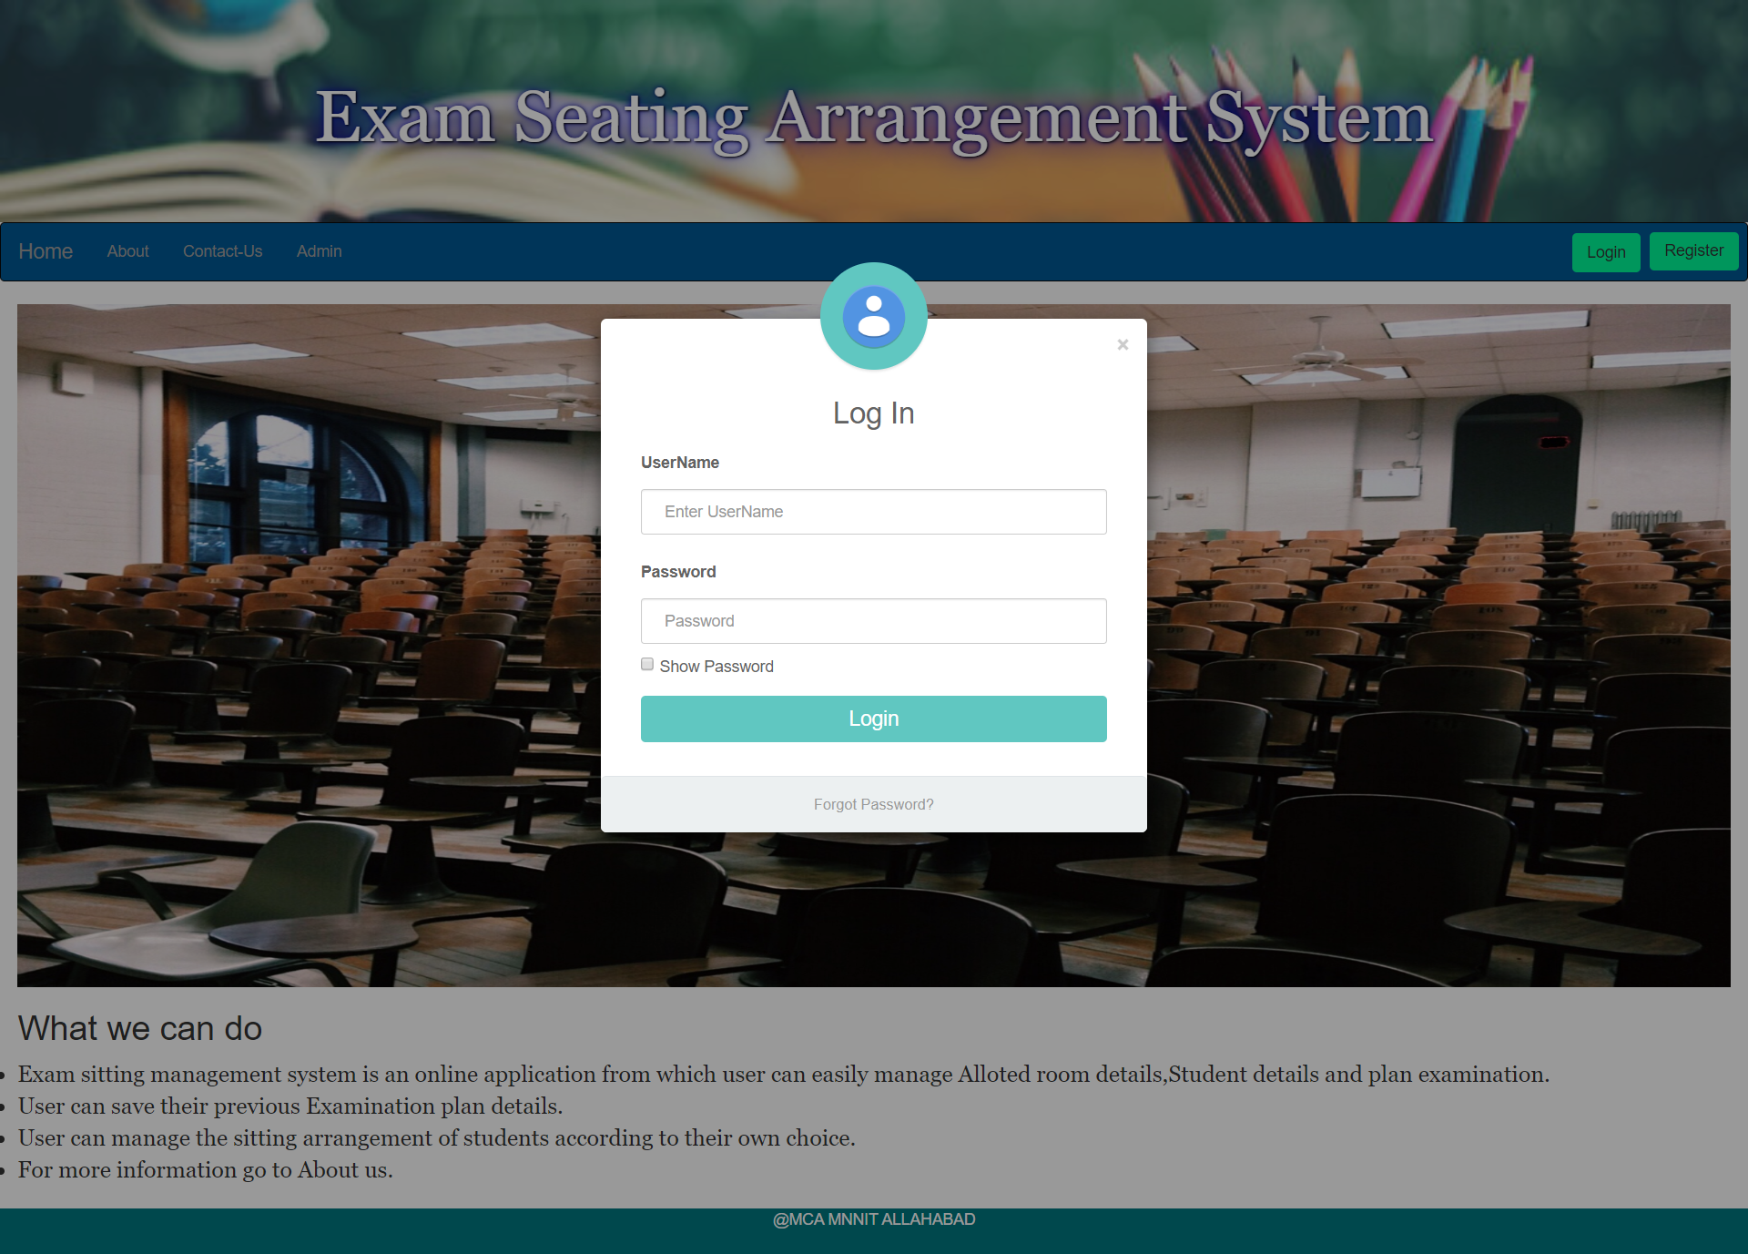

UserHome

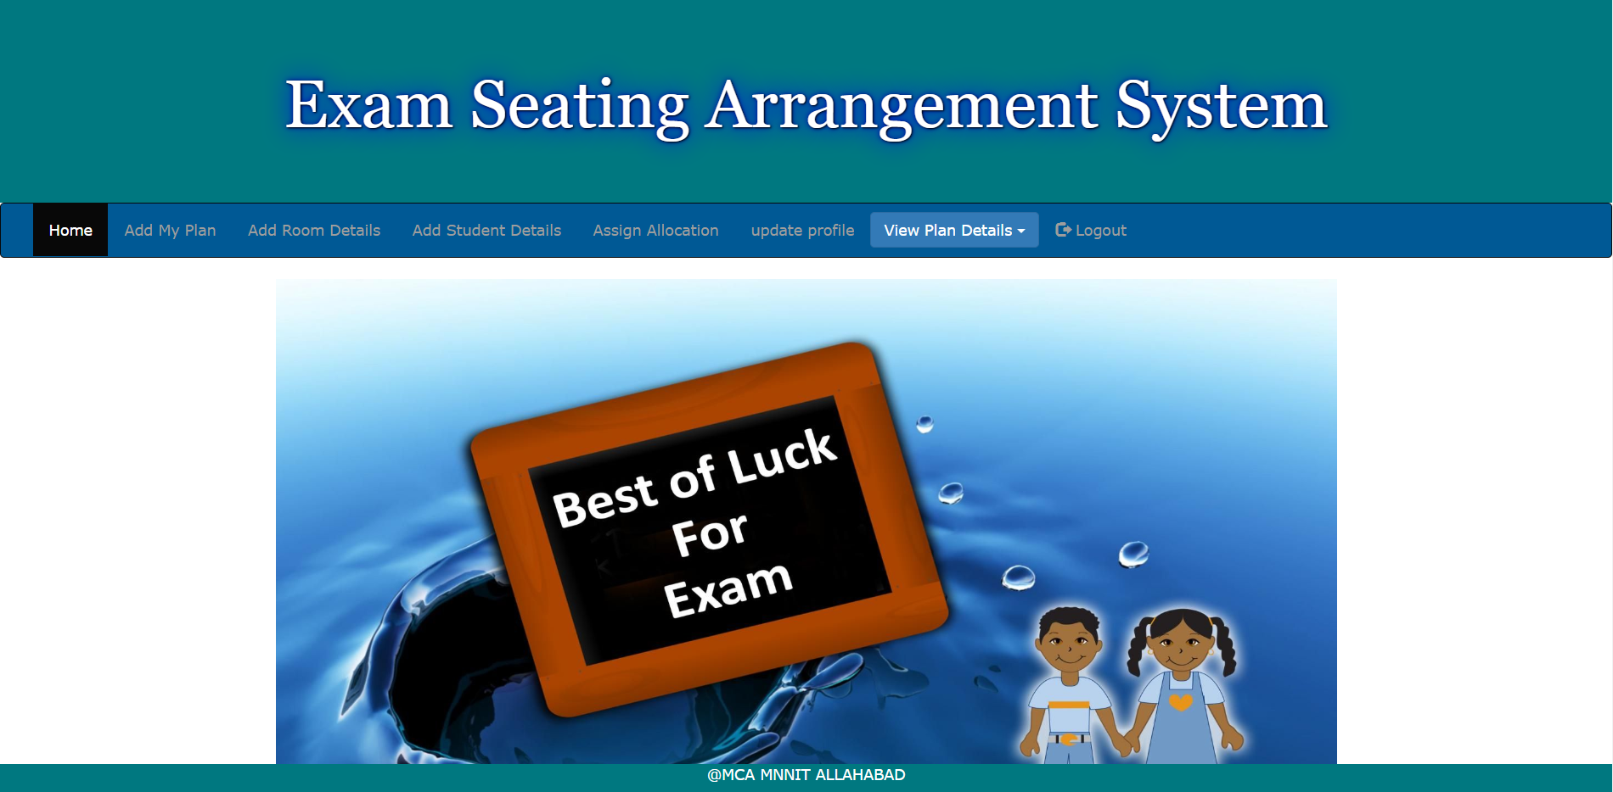

**ExamDetails**

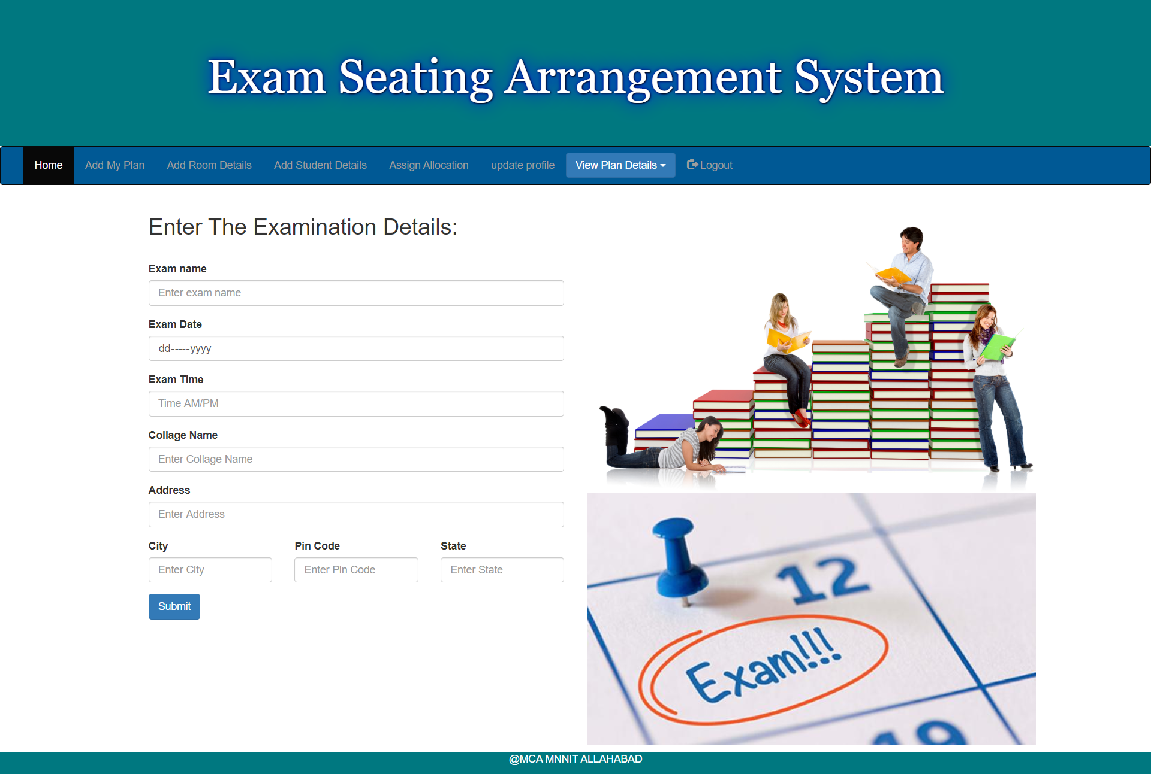

**RoomDetails**

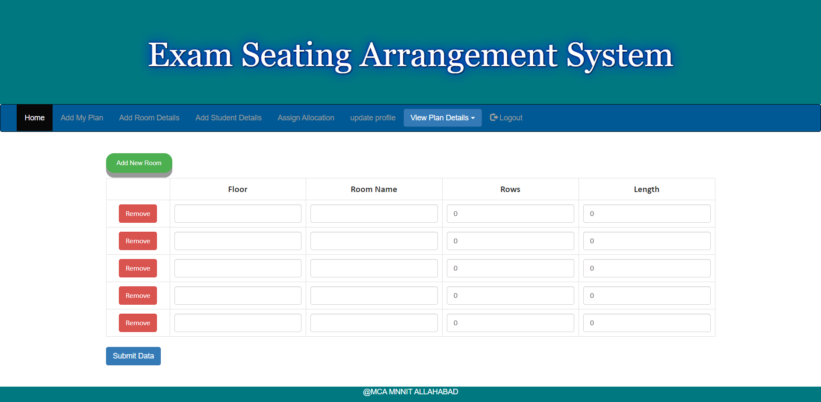

**Students Details**

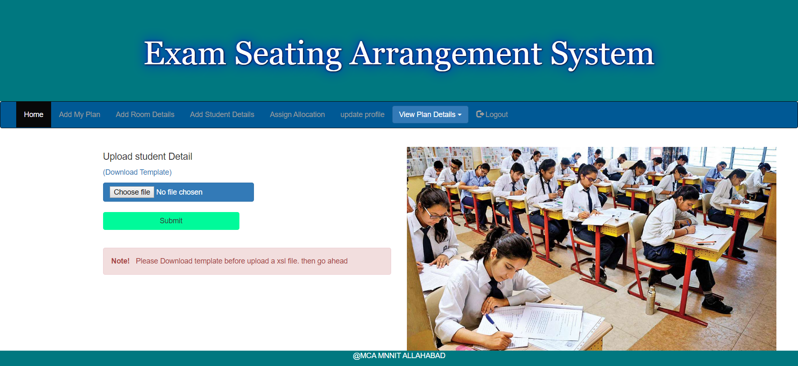

**AssignSeat**

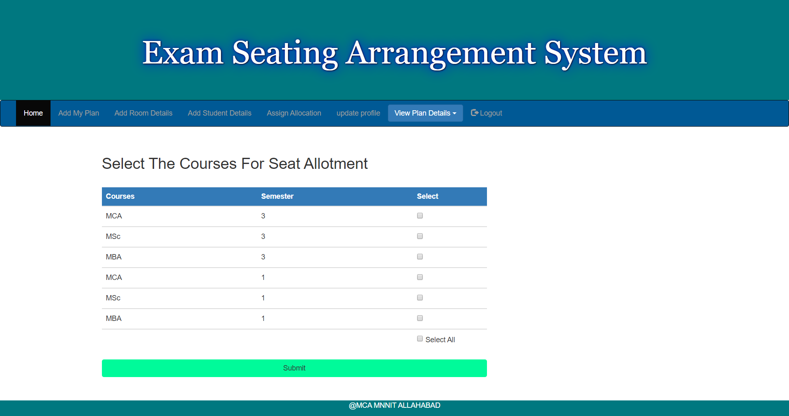

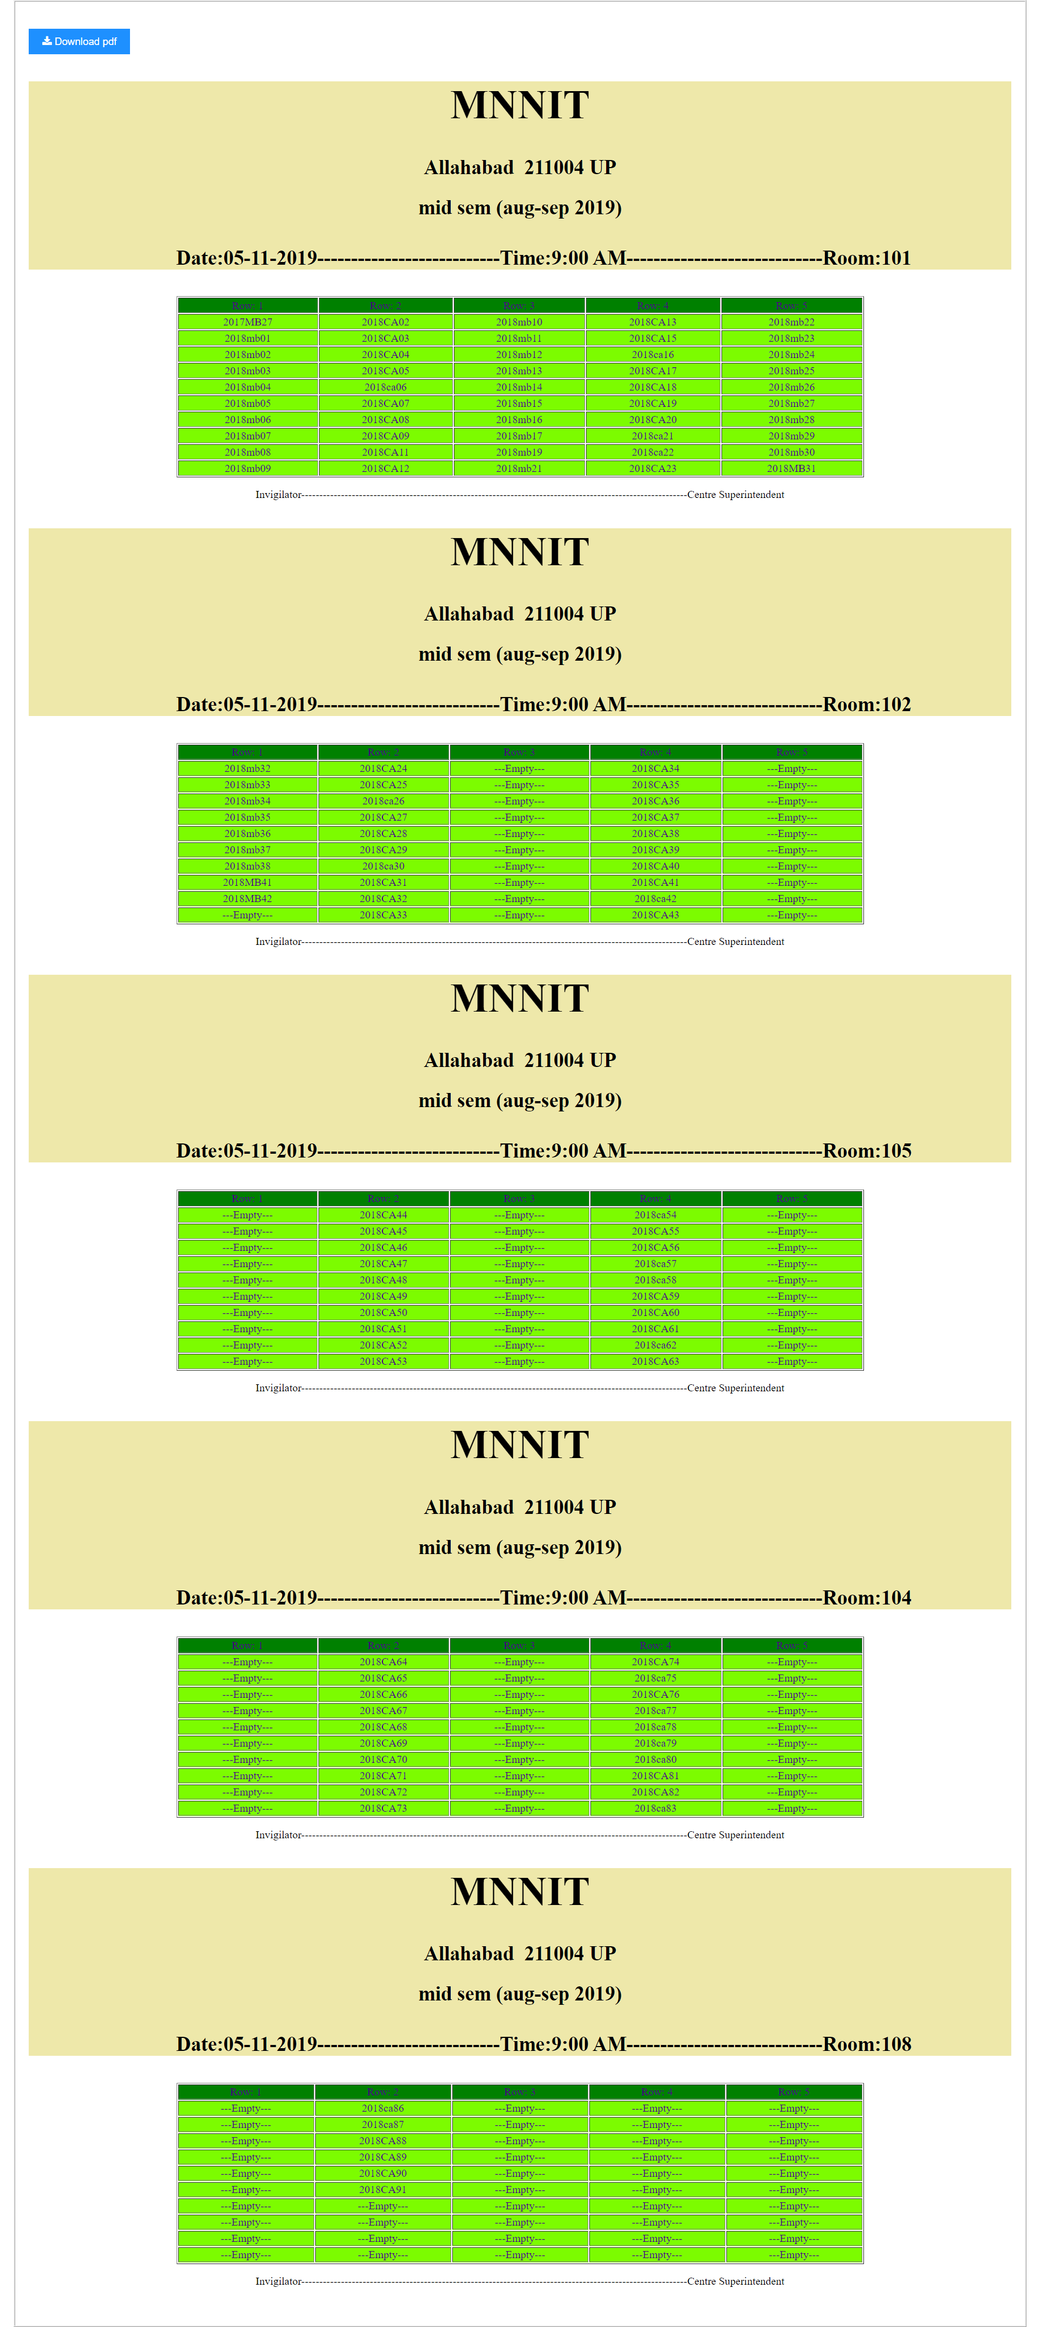

**Update Profile**

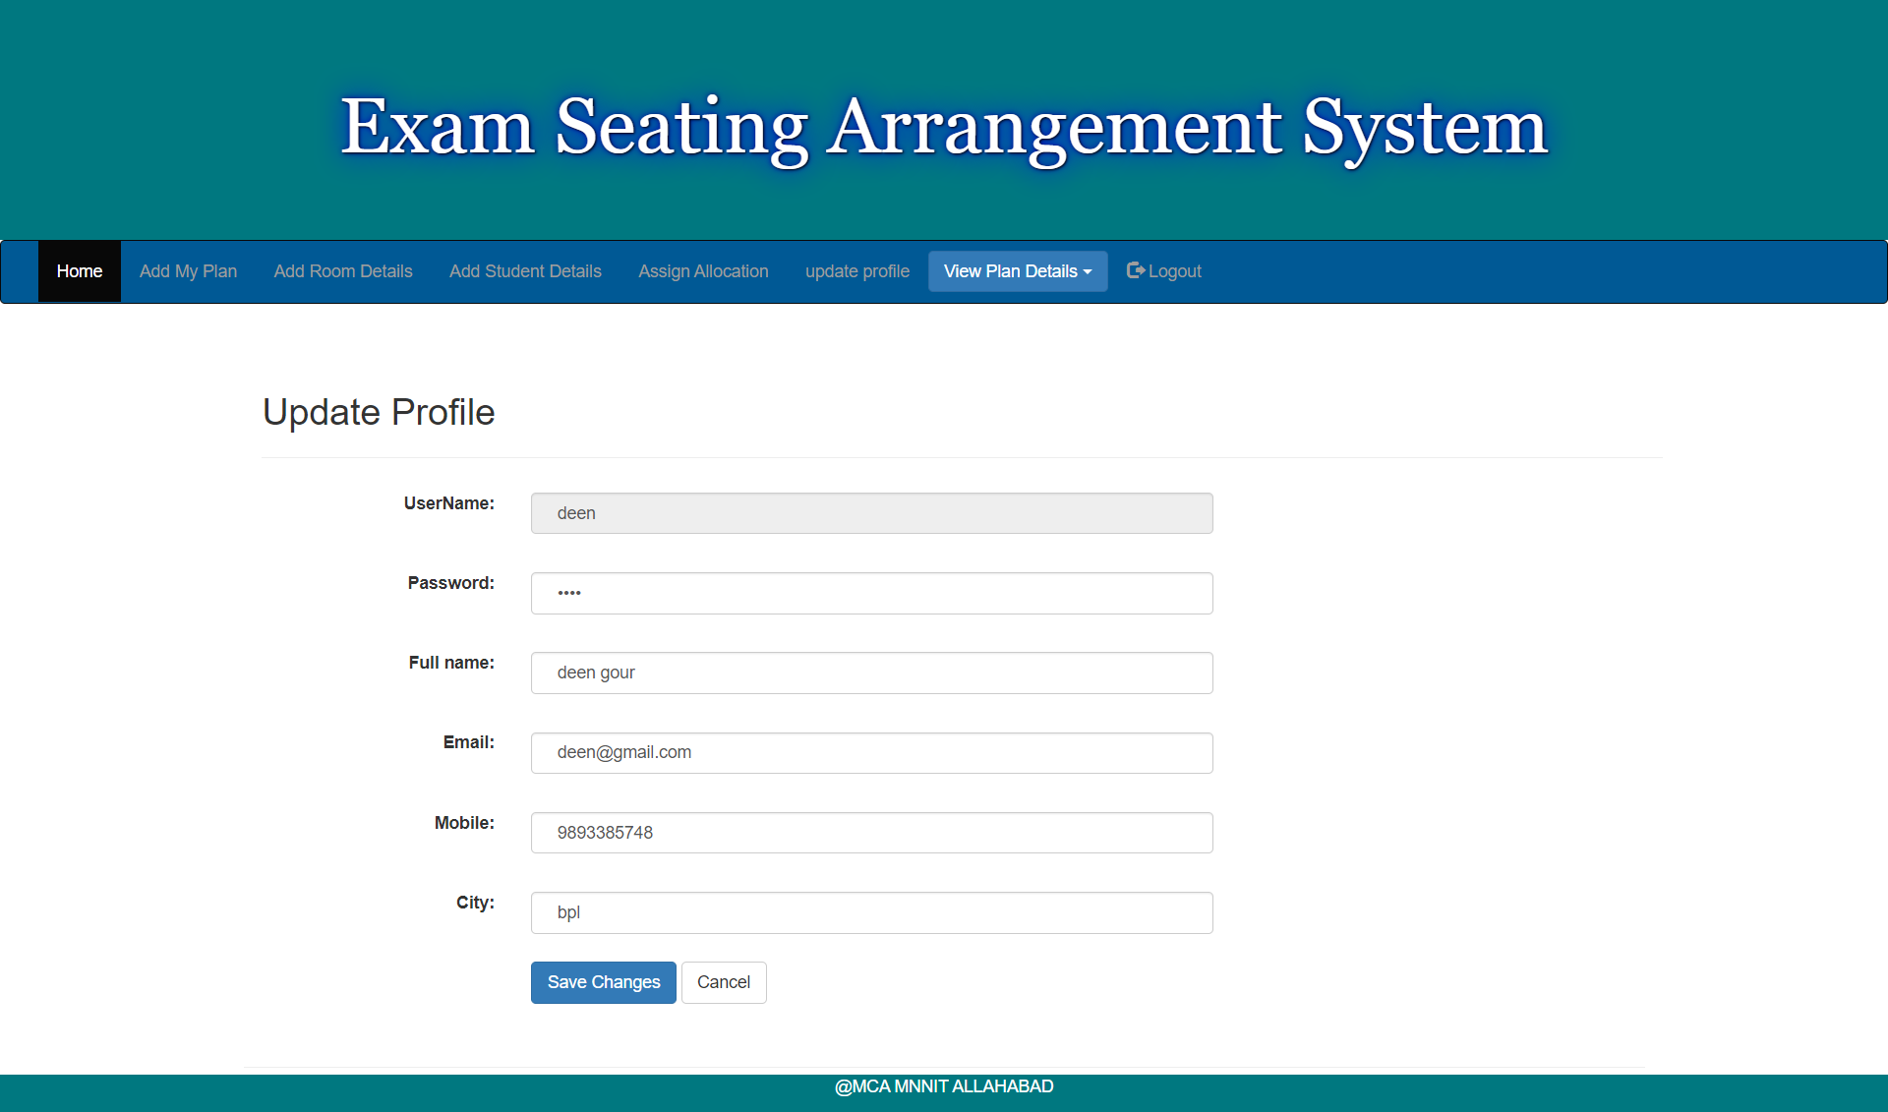

**View Exam Details**

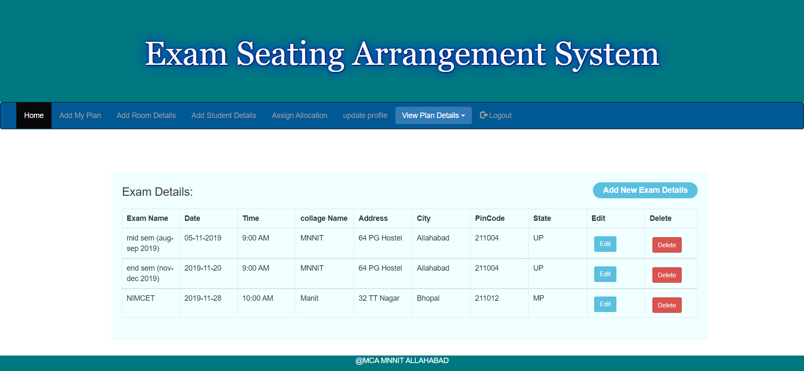

**Update Exam Details**

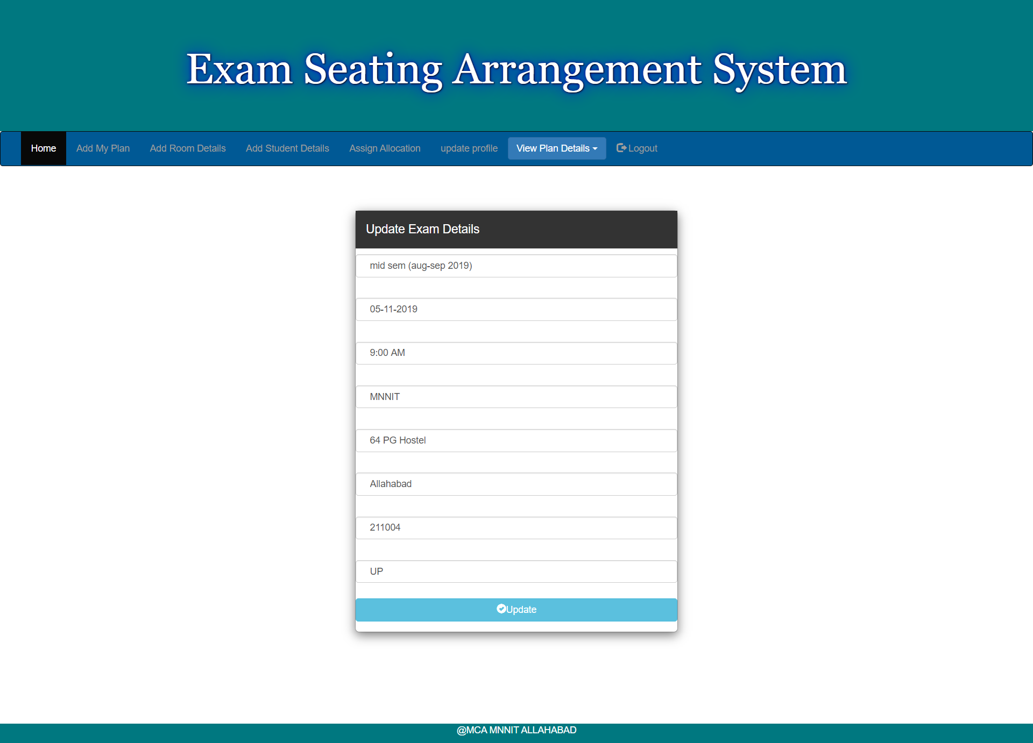

**View Room Details**

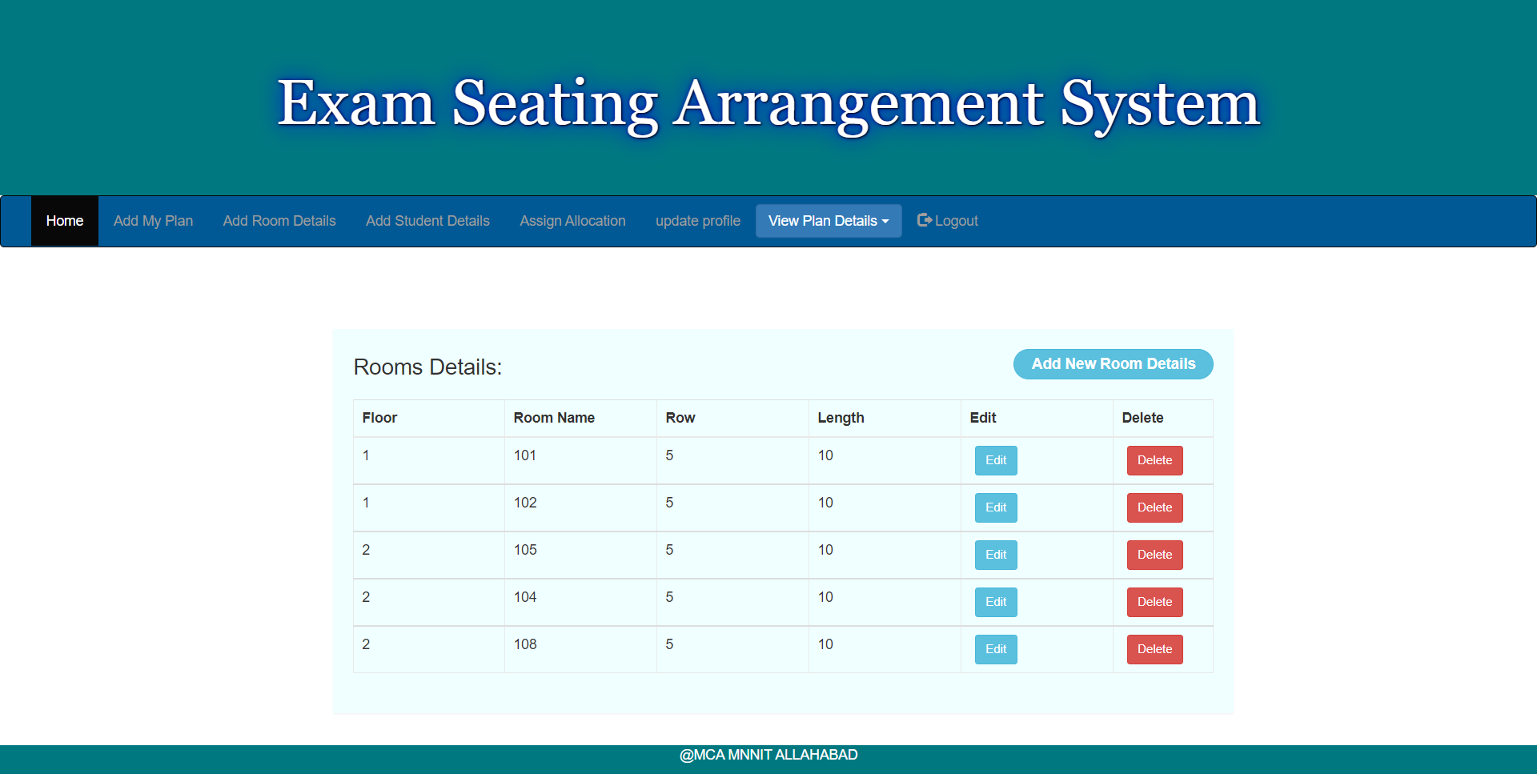

**Update Room Details**

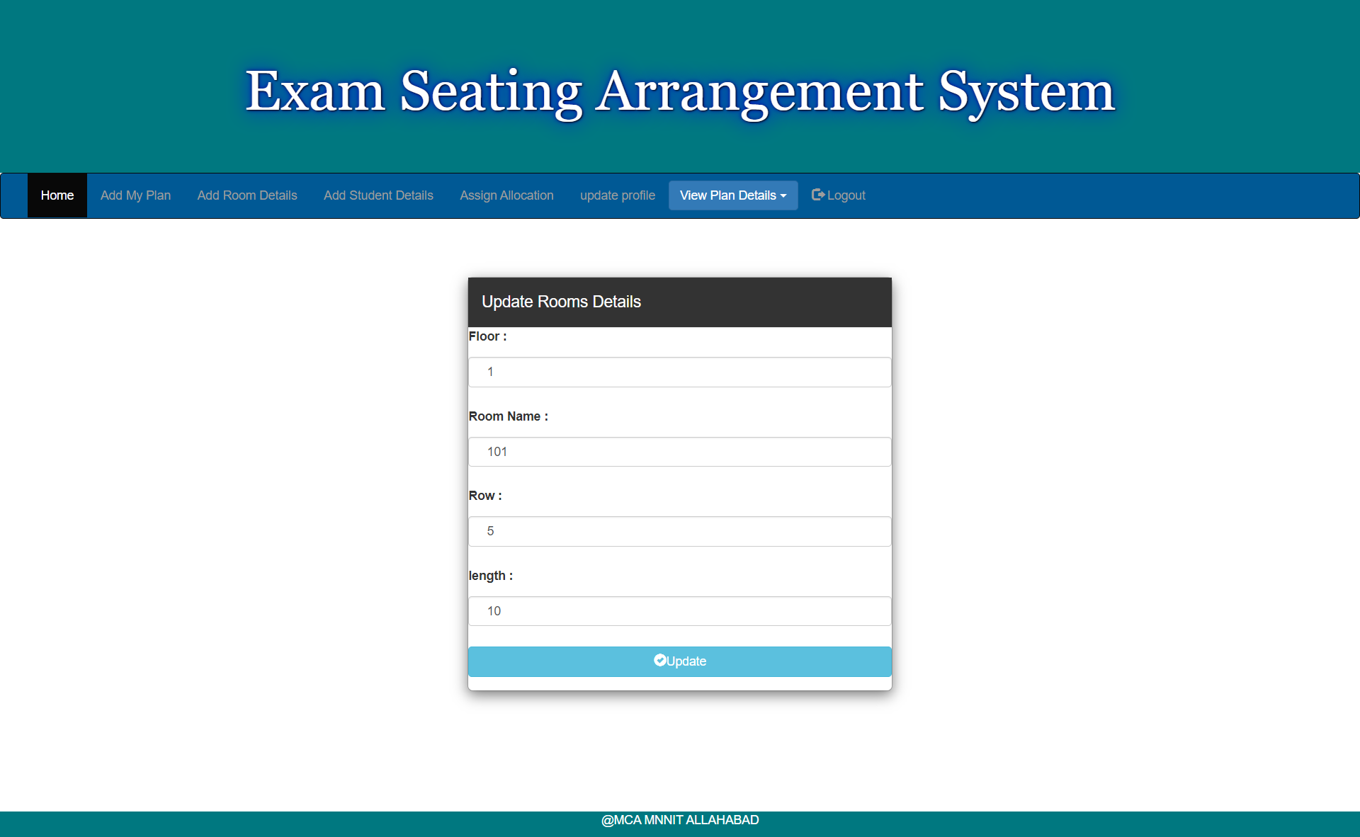

**Admin Login**

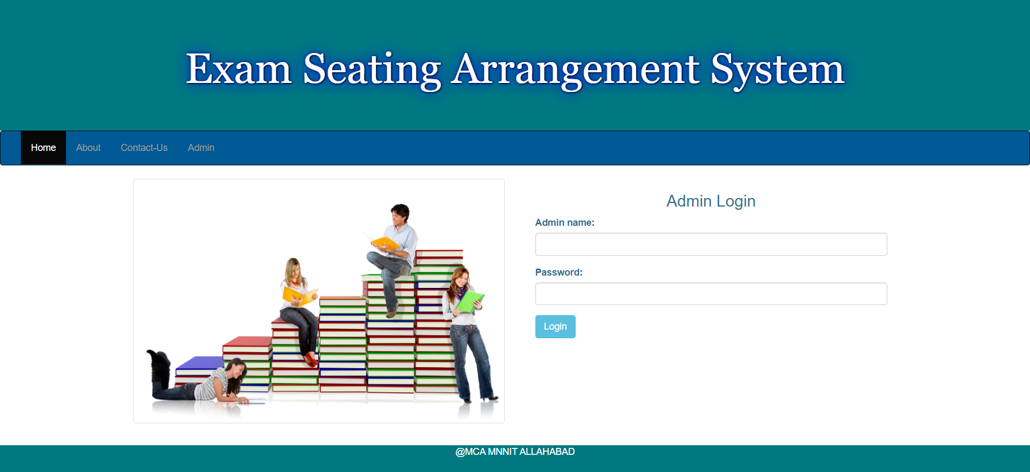

**Admin Home**

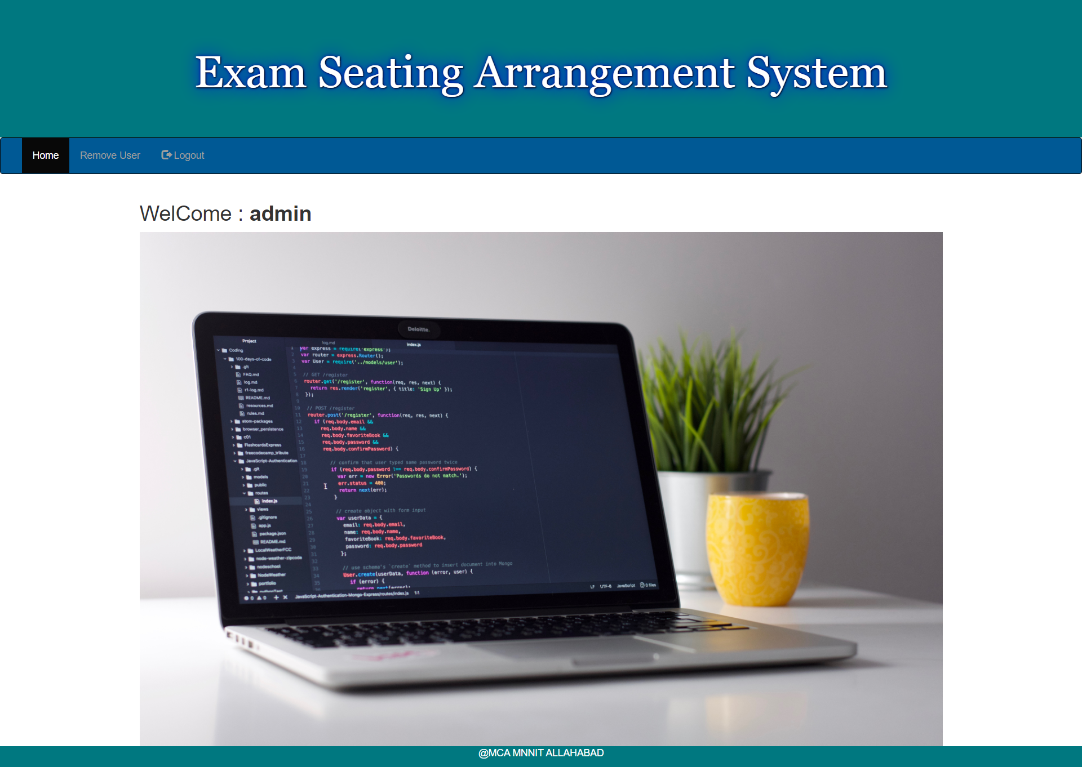

**Admin Remove User**

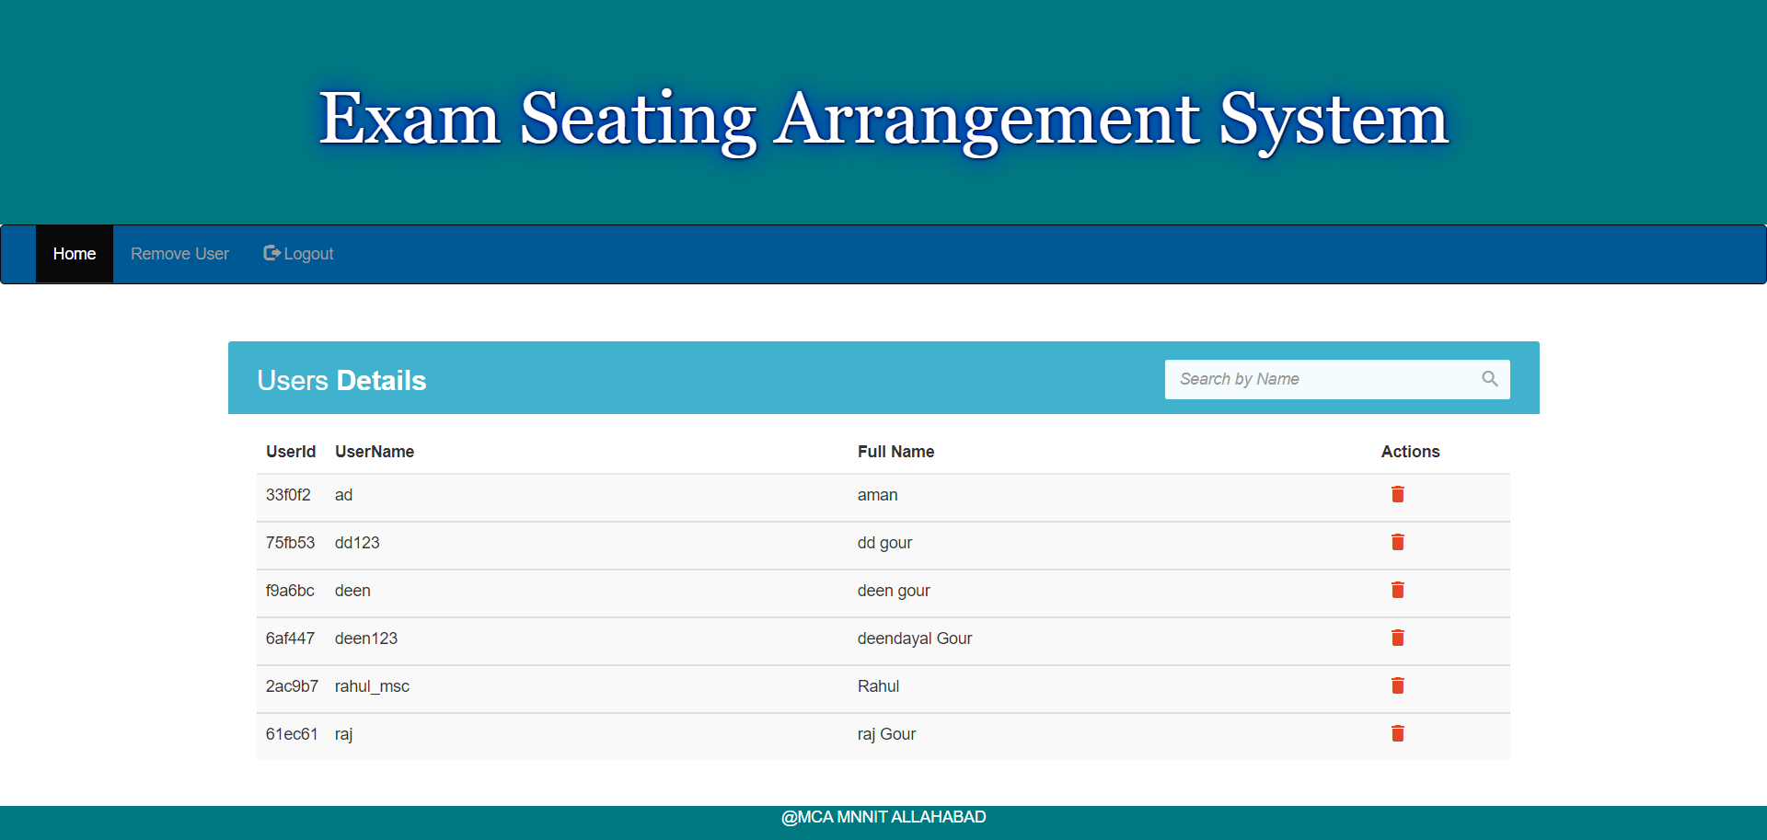

# Future Scope

We will made this system live and provide software as service in future.

Today, the market place is flooded with several exam seating arrangement system option for school and colleges to choose from . A variety of innovative product and services are being offered spoiling customers for choice. Student information system in no more a privilege enjoyed by manager and employees. In the last couple of year the growth of It industry has been phenomenal as more have started discovering the benefits of this using this platform therefore we will made a system as service live in future.

**Functionality to add:**

* We will create a student section in which student will be able to see its seating plan by giving required information.
* We will also provide email facility in which we will send email to each student which contain information about seating plan.
* There is also a scope of adding attendance of student in which only those student are allowed who has attendance greater than 75 % or whtatever the required attendance percentage.
* There will be a contact page also which lead user to contact us through mail services.

**Hardware Requirements**

RAM 4GB

Hard Disk 120GB

Processor Intel pentium processor

# Software Requirements

Operating System Windows, Linux ,macOS

Front Design Html, CSS, JavaScript, Bootstrap

Back-End MySQL, NODEJS

Framework Express